Counting Stem Lesson Ladder

PROGRESSION
Essential Foundational Knowledge (Roots) | - Say some number words  - Show awareness when there are different numbers of things  - Copy adult's item-by-item placement of objects  - Verbally count with distinct words but not necessarily in the correct order above five  - Put objects, actions, and words in many-to-one or overly rigid one-to-one correspondence
Leads to | - Addition and Subtraction  - Comparing and Ordering  - Place Value Concepts
Big Ideas | - Relationships between numbers and sets of objects  - Understanding numbers  - Pattern and structure  - Conservation of number  - Flexible and efficient counting  - Counting’s relationship to operations
Other Information

Concept/Skill: Say the numbers to 10 in the appropriate count sequence. (Megan-DONE)
Goal | Know the number names and the count sequence
Student-Facing Example | Ask the student to count out loud. You can quickly model counting to 3 if the student does not understand the task.  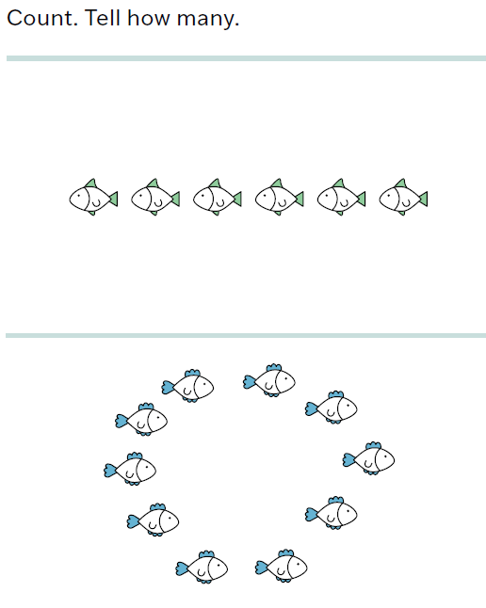
Knowledge Graph Node | Say the numbers to 10 in the appropriate count sequence.
Terminology | - Familiar Terms: Number  - Terminology: Counting, Whole number?
Mathematical Models
Strategies | - Songs, chants  - Fingers (Number Glove)
Specifications | - Say number names in the appropriate count sequence to 5 (PK, GK)  - Say number names in the appropriate count sequence to 10 (PK, GK)
Leaves to Include
Considerations | - Students might show some correspondence with objects but often exhibit performance errors in correspondence (e.g. skipping, double-counting).
Required Skills/Cases | - Say number names in the appropriate count sequence to 5 (PK, GK)  - Say number names in the appropriate count sequence to 10 (PK, GK)
Misconceptions | From TX BB GK M1:  - Students omit numbers from the counting sequence or count forward out of order.  - Incorporate counting practice throughout the day. Count everything, all the time. For example, you can count how many swings, trees, etc. are on the playground. Repeatedly hearing and saying the number words in the correct order will ensure proficiency of that order.
Existing Product Reference, if any | PK M1  GK M1
Grade (or Leaf) | PK, GK
Notes related to Standards, Grade, or Leaf | TX.K.2A (“to at least 20”)  MN.PK.M1.1 (“up to at least 29”)
Notes for Intervention, Extension, or Optional Activities | Intervention  - “Invite children to count with you. Then ask them to do it alone.”  - “Have the child mirror you, number by number. “Say each number after I say it. ‘One’” (pause).”  - “If children make mistakes, emphasize the importance of accuracy and encourage students to count slowly and carefully.” (Source: Doug and Julie)
Additional Notes | Fluency Ideas (from EM2 PK M1)  - Sunrise Counting  - Counting on the Number Glove  - Counting the Math Way  - Counting with Movement  - “I Can Count” song  - Counting on the Rekenrek to 10  Additional Notes  - “Initially, the counting words are a song to sing. Children learn at least some of this list as they do general language or the ABCs. Thus, rhythms and songs can play a role, although attention should be given to separating words from each other and understanding each as a counting word.” (Source: Doug and Julie)  Instructional Period  PK: 1  GK: 1  Associated Concepts from Other Stems  Whole Numbers and Base Ten Structure

Concept/Skill: Use cardinality and one-to-one correspondence to count groups of up to 10 objects, and represent the number of objects with a numeral. (Megan-DONE)

Goals | - Count to tell the number of objects  - Connect counting to cardinality
Student-Facing Example
Knowledge Graph Node | Say one number name with each object when counting up to 10 objects. | Say how many objects are in a group of up to 10 objects by using the last number of a count. | Represent a group of up to 10 objects with a numeral. | Represent a group of zero objects with the numeral 0.
Terminology
Mathematical Models | - Number path | - Number path | - Number path
Strategies | - Manipulatives, images  - Clap and count or move and count (one-to-one correspondence)  - Counting strategies:  - touch and count  - move and count  - mark and count | - Manipulatives, images  - Clap and count or move and count (one-to-one correspondence)  - Counting strategies:  - touch and count  - move and count  - mark and count | - Manipulatives, images  - Clap and count or move and count (one-to-one correspondence)  - Counting strategies:  - touch and count  - move and count  - mark and count
Specifications | - Groups of up to 5 objects (PK, GK)  - Groups of up to 10 objects (PK, GK)  - Move from concrete to pictorial contexts (i.e., physical objectspictures)  - Varied configurations (lineararray circularscattered) (PK, GK)  - Counting strategies (touch and count, move and count, mark and count) (PK, GK) | - Groups of up to 5 objects (PK, GK)  - Groups of up to 10 objects (PK, GK)  - Move from concrete to pictorial contexts (i.e., physical objectspictures)  - Varied configurations (lineararray circularscattered) (PK, GK)  - Consider what it is we’re counting. Include ambiguous examples with a discussion.  - Example: A picture of some frogs on a log, some frogs in the pond, and some frogs in the grass with the directive “Count the frogs” could lead to a discussion around which frogs we count.  - Example: 10 bags of apples with the question “How many apples” could lead to a discussion around whether we are counting the bags of apples or the apples in the bags.  - Differentiating between group and subgroups: How many red blocks? How many blue blocks? How many blocks? | - Groups of up to 5 objects (numerals 1-5) (PK, GK)  - Groups of up to 10 objects (numerals 6-10) (PK, GK)  - Begin with matching numerals to groups (PK, GK)  - Progress to writing numerals to represent how many (GK)  - Include instruction on numeral formation (see EM2 GK M1 TC and TF)  - “Air writing”, tracing, writing  - See numeral formation rhymes in GK M1 TC and TF  - Begin with writing rectangles that include dots (EM2)   | - Meaning of the word zero (PK, GK)  - Use zero to describe a group with no objects (PK, GK)  - Concrete and pictorial contexts (i.e., zero cookies on my plate and zero zebras in the picture) (PK, GK)  - Write the numeral zero to represent a group of zero objects (GK)
Leaves to Include
Considerations | - Arrangement of objects/images:  - Linear, array, circular, and scattered  - Number ranges (up to 5 and then up to 10)  - Consider matching objects to count (see TK-M1-L6)  - Counting Collections  - Common errors: skipping, double-counting |  | - Begin to read numerals and represent a number of objects with a written numeral
Required Skills/Cases | Uses one-to-one correspondence when given:  - Groups of up to 5 objects (PK, GK)  - Groups of up to 10 objects (PK, GK)  - Concrete and pictorial contexts (i.e., physical objects and pictures)  - Varied configurations (linear, array, circular, scattered) (PK, GK) | Tells how many when given:  - Groups of up to 5 objects (PK, GK)  - Groups of up to 10 objects (PK, GK)  - Concrete and pictorial contexts (i.e., physical objects and pictures)  - Varied configurations (linear, array, circular, scattered) (PK, GK) | - Show how many are in a group of up to 5 objects by matching a written numeral 1-5 (PK, GK)  - Show how many are in a group of up to 5 objects by writing a numeral 1-5 (GK)  - Show how many are in a group of 6 to 10 objects by matching a written numeral 6-10 (PK, GK)  - Show how many are in a group of 6 to 10 objects by writing a numeral 6-10 (GK) | - Understand that zero is a number that represents none and use the word zero to describe a group with no objects (PK, GK)  - Concrete and pictorial contexts (i.e., zero cookies on my plate and zero zebras in the picture) (PK, GK)  - Write the numeral 0; represent a group of zero objects with the numeral 0 (GK)
Misconceptions | From TX BB GK M1:  - Students skip objects or count objects more than once.  - Use tools such as a number  path to provide structure for one-to-one correspondence. Have students place objects on a number path or in a  box, a bag, or other container as they count. | From TX BB GK M1:  - Students repeat the count when asked “How many?” (e.g., “There are 1, 2, 3, 4, 5.”).  - Focus students’ attention on the last number name said to develop an understanding of cardinality. For example, you can use whisper-shout counting to draw attention to the last number word said. “Let’s whisper count, but when you get to the last number (point), shout the number!” | From TX BB GK M1:  - Students make reversals when writing numbers (e.g., “I wrote 2 backward.”).  - Use models and tools such as  writing rectangles to provide  structure and encourage  correct number formation.  Place the template for this and other models and tools in a personal white board to  support additional practice.
Existing Product Reference, if any | EM2 PK M1  EM2 GK M1 | EM2 PK M1  EM2 GK M1 | EM2 PK M1  EM2 GK M1 TC and TF | EM2 GK M1 L14  EM2 PK M1 L11
Grade (or Leaf) | PK, GK | PK, GK | PK, GK | PK, GK
Notes related to Standards, Grade, or Leaf | K.CC.B.4  K.CC.B.4.a  CA.K.CC.4  CA.K.CC.4.a  FL.K.NSO.1.1  TX.K.2C  NE.K.N.2.a | K.CC.B.4  K.CC.B.4.b  CA.K.CC.4  CA.K.CC.4.b  FL.K.NSO.1.1  TX.K.2C  NE.K.N.2.a | K.CC.B.4  K.CC.A.3  CA.K.CC.3  CA.K.CC.4  FL.K.NSO.1.1  TX.K.2B  VA.K.NS.2.c | K.CC.B.4  K.CC.A.3  CA.K.CC.3
Notes for Intervention, Extension, or Optional Activities | Intervention  - See Math Catalyst: Early Numeracy: Verbal and Object Counting to 5 and 10  - For one-to-one errors (includes keeping track of what’s been counted errors): “Emphasize the importance of accuracy and encourage the children to count slowly and carefully to “count each item exactly once.” When relevant, explain a keeping-track strategy. If moving objects is possible and desirable in the activity, suggest the strategy of moving items to a different pile or location. Otherwise, explain making a verbal plan, such as “Go from top to bottom. Start from the top and count every one” –then carry out the plan together.” (Source: Doug and Julie) | Intervention  - See Math Catalyst: Early Numeracy: Verbal and Object Counting to 5 and 10  - For cardinality (the “how many?” rule) errors, “Ask the children to re-count. Demonstrate the cardinality rule on the collection. That is, count the collection, pointing to each item in turn, stretch out the last counting word (“One, two, three, four, fiiivvve”) then gesture to them all, saying “Five in all!” (Source: Doug and Julie) | Intervention  - See Math Catalyst: Early Numeracy: Number Symbols to 10 | Intervention  - See Math Catalyst: Early Numeracy: Verbal and Object Counting to 10, Objective 4
Additional Notes | Fluency Ideas (from EM2 GK M1)  - Beans and Hands Mat  - Number Path Parking Lot  - Counting with Movement to 10  Additional Notes  - “Because there are really two correspondence – between saying the counting words and pointing, and between pointing and the objects – multiple experiences over a considerable time are often needed.” (Source: Learning Trajectories website--Corresponder)  - “When children enumerate, it’s about ordering: Keep the objects in order, keep the counting words in order, follow the procedure of enumeration one-by-one in sequence.” (Source: Doug and Julie)  Instructional Period-Up to 5 Objects  PK: 3  GK: 3  Instructional Period-Up to 10 Objects  PK: 3  GK: 3  (My thoughts on 3 days: gives time to introduce and use each counting strategy, gives time to introduce counting objects in varied configurations)  Associated Concepts from Other Stems  Whole Numbers and Base Ten Structure | Fluency Ideas (from EM2 GK M1)  - Beans and Hands Mat  - Whisper-Shout Counting  Additional Notes  - Cardinality concept = unifying the group (understanding the objects as a group) and quantifying the group (assigning a number to it) (Source: Doug and Julie)  - “However, at the end of counting, children have to switch from the order of the individuals to the cardinality, or “how-manyness”, of the whole group. This is the count to cardinal transition, and it’s not obvious.” (Source: Doug and Julie)  - Use the question “How many?” when teaching and assessing to help prompt children to make the count to cardinal transition. (Source: Doug and Julie)  Instructional Periods  PK: Likely part of other instructional periods (one-to-one correspondence)  GK: Likely part of other instructional periods (one-to-one correspondence)  Associated Concepts from Other Stems  Whole Numbers and Base Ten Structure | Fluency Ideas (from EM2 GK M1)  - Feel the Number fluencies  - Match: Sets and Numerals  Additional Notes  - “Using numerals (“1” or “4”) meaningfully helps children develop number concepts. Children may begin to use written representations for number as early as 3 years of age or as late as 6 years, depending on the home and preschool environments.” (Source: Doug and Julie)  - “Computer activities are another effective approach. After introducing numerals, the computer activities can ask children to respond to questions by clicking on a numeral (numerals are written on “cards” that initially have fives-and-tens frame dot representations as well), or read a numeral to know what size collection to produce. Children using these and other activities outperformed comparison groups that also were taught numerals.” (Source: Doug and Julie)  Instructional Period-Up to 5  PK: 2  GK: 2  (EM2 splits it numbers 1-3 and then 4-5)  Instructional Period-Up to 10  GK: 2-3  (EM2 splits it 6-7, 8, 9-10 for a total of 3 lessons)  Associated Concepts from Other Stems  Whole Numbers and Base Ten Structure | Additional Notes  - “Discussions of real-world knowledge of “nothing” or the number in set with no elements should begin early. Activities might include counting backward to zero, naming collections with zero, subtracting concrete objects to produce such collections, and discussing zero as the smallest whole number.” (Source: Doug and Julie)  - From EM2 GK M1 L14: Zero is the math word for none.  - Language Support box from EM2 PK M1 L11:  - Support students in understanding 0 by comparing the card with some leaves to a card with no leaves. Students will use a variety of words to describe 0, such as no, none, aren’t any, and zero. Look for opportunities to use the word zero during the school day to help students build meaning.  Instructional Period  PK: 1  GK: 1  Associated Concepts from Other Stems  Whole Numbers and Base Ten Structure

Concept/Skill: Count out a group of up to 10 objects. (Megan-DONE)
Goal | Count out a given number of objects from a larger group
Student-Facing Example | 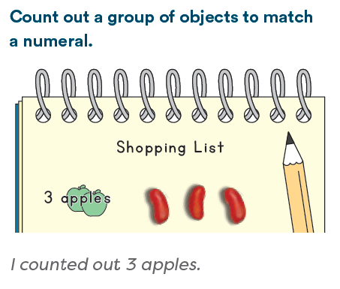
Knowledge Graph Node | Count out a group of up to 10 objects.
Terminology
Mathematical Models
Strategies | - Manipulatives  - Contexts
Specifications | - Up to 5 objects  - Up to 10 objects  - Count out a set to match a number presented orally (“Give me 5 ___”)  - Count out a set to match a written numeral (first by identifying the written numeral, and then by counting out that many)  - Count out “enough” objects in contexts up to 10  - Determine how many are needed (i.e., by counting people in the group) and count out that many, ensuring one-to-one correspondence (i.e., each person gets one)  - Attend to the target number and know when to stop counting  - Use one-to-one correspondence, keep track of the number word they are on, compare the number word they are on to the target number, and stop when they reach the target number
Leaves to Include
Considerations | - Variations: Numbers given verbally and/or written as numerals  - Consider a collection of no objects  - Counting out a group requires multitasking since students must remember the target number, say the number words in order, and attend to one-to-one correspondence all at the same time  - Provides a new reason for counting: to create a group of a specific size  - An authentic context where counting out and determining "enough" is needed  - The trajectory levels Counter (10) and Producer (Small Numbers) are close and children may develop Producer (Small Numbers) at the same time or even after Counter (10)
Required Skills/Cases | - Up to 5 objects  - Up to 10 objects  - Count out a set to match a number presented orally (“Give me 5 ___”)  - Count out a set to match a written numeral  - Count out “enough” objects in contexts up to 10  - Count out physical objects or circle pictures  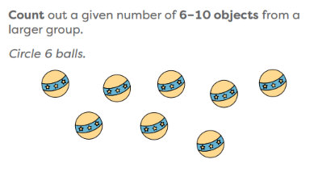
Misconceptions | - Counting out objects past the target number or counting out too few
Existing Product Reference, if any | EM2 GK M1 L10  EM2 GK M1 L13 (“enough”)  EM2 GK M1 L24
Grade (or Leaf) | PK, GK
Notes related to Standards, Grade, or Leaf | K.CC.B.4  K.CC.B.4.a  K.CC.B.4.b  K.CC.B.5  FL.K.NSO.1.2  NE.K.N.2.c  TX.K.2.B  TX.K.2E  VA.K.NS.2.b
Notes for Intervention, Extension, or Optional Activities | Intervention  - See Math Catalyst: Early Numeracy: Number Symbols to 10, Objective 3 (Count out a group objects to match the numerals 6-10)
Additional Notes | Additional Notes  - “To produce 4, children have to keep track of the number word they are on, and keep one-to-one correspondence, and compare the number word they said to the 4 with each count. Before they reach that level of competence, they often just keep going!” Source: Doug and Julie  - “Producing a set number of items is typically more difficult than counting a collection of items. Children have to keep the target number in mind at all times and stop themselves when they reach it.” (Source: Learning Trajectories website--Producer Small Numbers)  Instructional Period-Up to 5 objects  PK: 1  GK: 1  Instructional Period-Up to 10 objects  PK: 1  GK: 1  Associated Concepts from Other Stems  Whole Numbers and Base Ten Structure

Concept/Skill: Count and count out groups of more than 10 objects. (Megan-DONE)

Goals | - Count to tell the number of objects  - Count out a given number of objects from a larger group
Student-Facing Example | 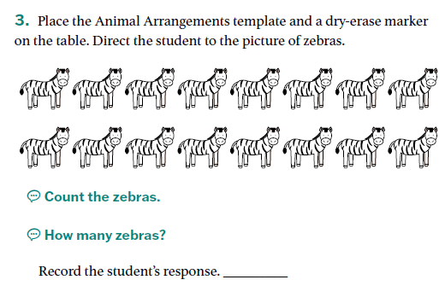 |  | 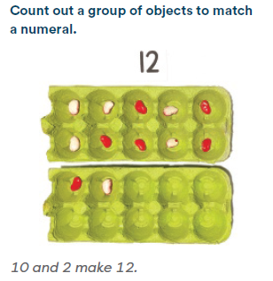
Knowledge Graph Node | Count a group of 11-20 objects to tell how many objects are in the group. | Represent a group of 11-20 objects with a numeral. |  | Count out a group of 11-20 objects. | Count a group of more than 20 objects to tell how many objects are in the group. | Represent a group of more than 20 objects with a numeral. | Count out a group of more than 20 objects.
Terminology
Mathematical Models | - Number path and other organizational tools  - 10-Frames | - Number path and other organizational tools  - 10-Frames |  | - Number path and other organizational tools  - 10-Frames | - Number path and other organizational tools  - 10-Frames | - Number path and other organizational tools  - 10-Frames | - Number path and other organizational tools  - 10-Frames
Strategies | - Manipulatives, images  - Counting strategies:  - touch and count  - move and count  - mark and count  - Wu’s “counting array”  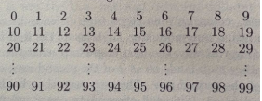 | - Manipulatives, images  - Counting strategies:  - touch and count  - move and count  - mark and count  - Wu’s “counting array” |  | - Manipulatives, images  - Counting strategies:  - touch and count  - move and count  - mark and count  - Wu’s “counting array” | - Manipulatives, images  - Counting strategies:  - touch and count  - move and count  - mark and count  - Wu’s “counting array” | - Manipulatives, images  - Counting strategies:  - touch and count  - move and count  - mark and count  - Wu’s “counting array” | - Manipulatives, images  - Counting strategies:  - touch and count  - move and count  - mark and count  - Wu’s “counting array”
Specifications | - Groups of 11 to 20 objects  - Count as 10 ones and some more ones  - Move from concrete to pictorial contexts (i.e., physical objectpictures)  - Varied configurations (linear, array, circular, scattered)  - Apply counting strategies to help track the count  - Touch and Count  - Move and Count  - Mark and Count  - Incorporate organizational tools, such as 10-frames/10-frame cartons  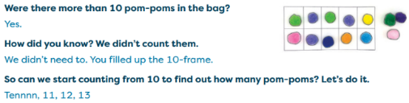  - Begin to use organizational strategies, such as organizing objects into a group of 10 and counting from 10 (Tennn, 11, 12, 13)  - Keep track of objects that have and have not been counted  - Answer the question “how many?” with the last number counted  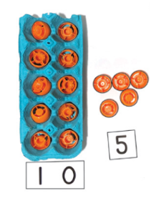  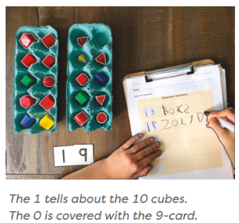  - Separate the decade and the ones part of a number word and begin to relate each part of a number word/numeral to the quantity to which it refers (incorporate Hide Zero cards—see GK M6 TA)  - Recognize errors in others’ counting and correct own counting errors  - Consider what it is we’re counting. Include ambiguous examples with a discussion.  - Example: A picture of some frogs on a log, some frogs in the pond, and some frogs in the grass with the directive “Count the frogs” could lead to a discussion around which frogs we count.  - Example: 10 bags of apples with the question “How many apples” could lead to a discussion around whether we are counting the bags of apples or the apples in the bags.  - Differentiating between group and subgroups: How many red blocks? How many blue blocks? How many blocks? | - Groups of 11-20 objects  - Begin with matching numerals to groups  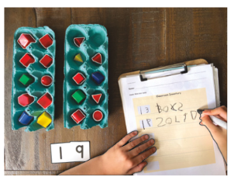  - Incorporate Hide Zero cards  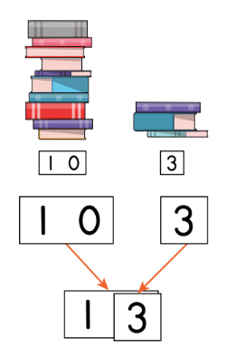  - Progress to writing numerals to represent how many |  | - Groups of 11-20 objects  - Count out a set to match a number presented orally (“Give me 15 ___”)  - Count out a set to match a written numeral (first by identifying the written numeral, and then by counting out that many)  - Count out “enough” objects in contexts up to 20  - Determine how many are needed (i.e., by counting people in the group) and count out that many, ensuring one-to-one correspondence (i.e., each person gets one)  - Attend to the target number and know when to stop counting  - Use one-to-one correspondence, keep track of the number word they are on, compare the number word they are on to the target number, and stop when they reach the target number | - Groups of 21-30 objects  - Groups of more than 30 objects  - Count by ones  - Count by tens  - Count by tens and ones  - Move from concrete to pictorial contexts (i.e., physical objectpictures)  - Varied configurations (linear, array, circular, scattered)  - Apply counting strategies to help track the count  - Touch and Count  - Move and Count  - Mark and Count  - Incorporate organizational tools, such as 10-frames/10-frame cartons  - Use organizational strategies, such as organizing objects into groups of 10 and counting by tens and ones (10, 20, 21, 22, 23)  - Keep track of objects that have and have not been counted  - Answer the question “how many?” with the last number counted  - Separate the decade and the ones part of a number word and begin to relate each part of a number word/numeral to the quantity to which it refers  - Recognize errors in others’ counting and correct own counting errors  - Consider what it is we’re counting. Include ambiguous examples with a discussion.  - Example: A picture of some frogs on a log, some frogs in the pond, and some frogs in the grass with the directive “Count the frogs” could lead to a discussion around which frogs we count.  - Example: 10 bags of apples with the question “How many apples” could lead to a discussion around whether we are counting the bags of apples or the apples in the bags.  - Differentiating between group and subgroups: How many red blocks? How many blue blocks? How many blocks? | - Groups of 21-30 objects  - Groups of more than 30 objects  - Begin with matching numerals to groups  - Incorporate Hide Zero cards  - Progress to writing numerals to represent how many | - Groups of 21-30 objects  - Groups of more than 30 objects  - Count out a set to match a number presented orally (“Give me 25 ___”)  - Count out a set to match a written numeral (first by identifying the written numeral, and then by counting out that many)  - Count out “enough” objects in contexts up to 30 and then beyond 30  - Determine how many are needed (i.e., by counting people in the group) and count out that many, ensuring one-to-one correspondence (i.e., each person gets one)  - Attend to the target number and know when to stop counting  - Use one-to-one correspondence, keep track of the number word they are on, compare the number word they are on to the target number, and stop when they reach the target number
Leaves to Include | - Read numerals beyond 10  - Write and draw to represent counts | - Read numerals beyond 10  - Write and draw to represent counts |  | - Write and draw to represent counts | - Read numerals beyond 10  - Write and draw to represent counts | - Read numerals beyond 10  - Write and draw to represent counts | - Read numerals beyond 10  - Write and draw to represent counts
Considerations | - Number ranges: to 20  - Include 0  - Explicit understanding of cardinality  - Keep track of objects that have and have not been counted  - Give the very next number (usually to 20s or 30s), especially if allowed to generate a "running start."  - Separate the decade and the ones part of a number word and begin to relate each part of a number word/numeral to the quantity to which it refers.  - Recognize errors in others’ counting and can eliminate most errors in own counting  - Counting Collections  - Arrangement of objects/images:  - Linear, array, circular, and scattered |  |  | - Contexts for counting out a set of objects | - Number ranges: to 30, beyond 30  - Give the very next number (usually to 20s or 30s), especially if allowed to generate a "running start."
Required Skills/Cases | - 11 to 20 objects  - Concrete and pictorial contexts (i.e., physical objects and pictures of objects)  - Varied configurations (linear, array, circular, scattered)  - Include arrangements that support using groupings to count | - 11 to 20 objects  - Show how many are in a group of 11 to 20 objects by matching a written numeral (11-20)  - Show how many are in a group of 11 to 20 objects by writing a numeral (11-20) |  | - 11 to 20 objects  - Count out a set to match a number presented orally (“Give me 15 ___”)  - Count out a set to match a written numeral  - Count out “enough” objects in contexts up to 20  - Count out physical objects or circle pictures  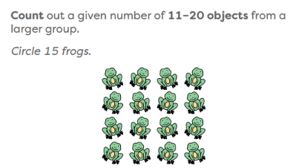 | - 21 to 30 objects  - More than 30 objects  - Concrete and pictorial contexts (i.e., physical objects and pictures of objects)  - Varied configurations (linear, array, circular, scattered)  - Include arrangements that support counting by tens and by tens and ones | - 21 to 30 objects  - More than 30 objects  - Show how many are in a group of 21 to 30 objects by matching a written numeral 21-30  - Show how many are in a group of 21 to 30 objects by writing a numeral 21-30  - Show how many are in a group of more than 30 objects by matching a written numeral beyond 30  - Show how many are in a group of more than 30 objects by writing a numeral beyond 30 | - 21 to 30 objects  - More than 30 objects  - Count out a set to match a number 21-30 presented orally (“Give me 25 ___”)  - Count out a set to match a written numeral 21-30  - Count out “enough” objects in contexts of 21-30  - Count out a set to match a number greater than 30 presented orally (“Give me 42 ___”)  - Count out a set to match a written numeral greater than 30  - Count out “enough” objects in contexts greater than 30  - Count out physical objects or circle pictures
Misconceptions | From TX BB GK M1:  - Students skip objects or count objects more than once.  - Use tools such as a number  path to provide structure for one-to-one correspondence. Have students place objects on a number path or in a  box, a bag, or other container as they count.  From TX BB GK M5:  - Students count all, even with small quantities (e.g., “I have to count each object to tell how many.”)  - Notice how counting within 20 on a Rekenrek the Say Ten way helps students visualize numbers and recognize the 10 in a teen number. | From TX BB GK M5:  - Students use the pronunciation of teen numbers as a basis for writing digits (e.g., fourteen is written as 41  instead of 14)  - Notice how Say Ten counting highlights the base-ten structure within teen numbers. Place value cards support understanding that the digit 1 in a teen number represents 10 ones.
Existing Product Reference, if any | GK M6 TA  GK Strawman Lesson 1 | EM2 GK M6 TA L3  GK Strawman Lesson 1 |  | EM2 GK M6 TA L6  GK Strawman Lesson 2 | EM2 GK M6 TC  Counting Collections lessons (See G1 M1 TD L25) | EM2 G1 M6 Topic D (Count and Represent Numbers Beyond 100) | EM2 GK M6 TC  EM2 G1 M6 Topic D
Grade (or Leaf) | GK | GK |  | GK | G1 | G1 | G1
Notes related to Standards, Grade, or Leaf | K.CC.B.5  CA.K.CC.5  TX.K.2A  TX.K.2C  FL.K.NSO.1.1  IA.PK.7.1.PS.3 | K.CC.A.3  CA.K.CC.3  TX.K.2B  FL.K.NSO.1.1  VA.K.NS.2.c |  | K.CC.B.5  CA.K.CC.5  FL.K.NSO.1.2  TX.K.2A  TX.K.2B  TX.K.2E  NE.K.N.2.c  VA.K.NS.2.b | MN.1.3.5.1 | 1.NBT.A.1  CA.1.NBT.1  VA.K.NS.2.c | VA.K.NS.2.b
Notes for Intervention, Extension, or Optional Activities | Intervention  - See Math Catalyst: Early Numeracy: Verbal and Object Counting to 20  - “For children who are unable to keep track, first suggest they count slowly and carefully; ask them to count each item exactly once, touching items as they count. Next, model strategies and/or help children invent strategies that work for them, such as moving items to a new location as they are counted; counting top to bottom or left to right (“reading order”); or, for circular arrangements, counting at a set place by starting with a certain color, shape, or other criterion.” (Source: Learning Trajectories website)  Extension  - As GK students are ready, consider increasing the number of objects to extend beyond 20 (see nodes 4-6). | Intervention  - See Math Catalyst: Early Numeracy: Number Symbols to 20 (Objectives 1 and 2)  Extension  - As GK students are ready, consider increasing the number of objects to extend beyond 20 (see nodes 4-6). |  | Intervention  - See Math Catalyst: Early Numeracy: Number Symbols to 20 (Objective 3)  Extension  - As GK students are ready, consider increasing the number of objects to extend beyond 20 (see nodes 4-6).
Additional Notes | Fluency Ideas  - Counting on the Rekenrek (EM2 GK M6)  Additional Notes  - “The counting skill of keeping track of unordered items is a special type of one-to-one correspondence task.” (Source: Learning Trajectories website)  Instructional Period  2-3  Associated Concepts from Other Stems  Whole Numbers and Base Ten Structure | Instructional Period  2  Associated Concepts from Other Stems  Whole Numbers and Base Ten Structure |  | Additional Notes  - “Producing a set number of items is typically more difficult than counting a collection of items. Children have to keep the target number in mind at all times and stop themselves when they reach it and with larger numbers, there are more demands on their working memories.” (Source: Learning Trajectories website)  Instructional Period  1  Associated Concepts from Other Stems  Whole Numbers and Base Ten Structure | Additional Notes  “The counting skill of keeping track of unordered items is a special type of one-to-one correspondence task.” Source: Learning Trajectories website  Instructional Period  1 or this might also live in Practice/Fluency  Associated Concepts from Other Stems  Whole Numbers and Base Ten Structure | Instructional Period  Likely part of other instructional period (previous node)  Associated Concepts from Other Stems  Whole Numbers and Base Ten Structure | Additional Notes  - “Producing a set number of items is typically more difficult than counting a collection of items. Children have to keep the target number in mind at all times and stop themselves when they reach it and with larger numbers, there are more demands on their working memories.” Source: Learning Trajectories website  Instructional Period  1 or this might also live in Practice/Fluency  Associated Concepts from Other Stems  Whole Numbers and Base Ten Structure

Concept/Skill: Count on from a number other than 1, and name the number that is 1 more or 1 less than a given number. (Megan-DONE)

Goal | Count on from a given number and identify 1 more and 1 less than a given number (just before, just after)
Student-Facing Example | 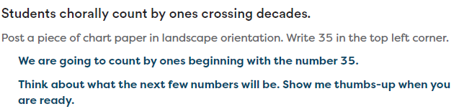 |  | 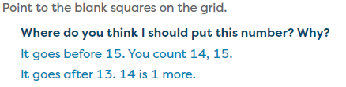
Knowledge Graph Node | Count on from a given number. | Determine the numbers that are 1 more and 1 less than a given number.
Terminology
Mathematical Models | Number path/line | Number path/line
Strategies | - Choral counting  - Wu’s “counting array” | - Choral counting  - Wu’s “counting array”
Specifications | - Possible distinguisher from other counting on skills/nodes: In this node, students do not yet have to keep track of the number of counts  - Count on with objects  - See Learning Trajectories Counter from N (N+1, N-1) Activities (focus on counting forward):  - Start small: add one object to a small group so students count on one  - Increase number of objects added or group size as students are ready  - Verbal Counting  - Consider offering scaffolding (children hear someone else count and pick up where they left off—see Learning Trajectories Counter from N activity “Counting Wand: What Comes Next?”)  - Chorally count on from a number other than 1 and record on chart paper  - Cross decades  - Identify patterns  - Ranges:  - GK with objects/pictures: within 5, then within 10  - GK verbal: within 100  - G1 with objects/pictures: within 20  - G1 verbal: within 120 | - Model the pattern of 1 more in the forward count sequence and 1 less in the backward count sequence by incorporating a concrete representation like number stairs. Include 1 more counting (“1; 1 more is 2. 2; 1 more is 3”) and 1 less counting (“10; 1 less is 9. 9; 1 less is 8”).  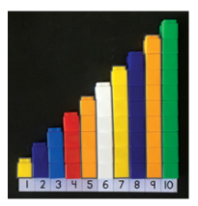  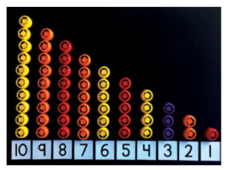  (See EM2 GK M1 and M6)  - Concrete (with number stairs and models)Abstract (numbers presented in writing or orally)  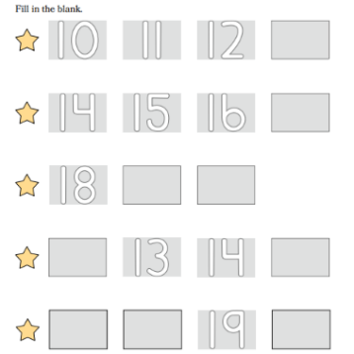  - Offer the number path, number line, and/or Wu’s counting array as a visual for students to reference as they build skill in determining 1 more, 1 less (just before, just after)  - Begin with numbers 1-10 (early in GK) before extending to 20 (later in GK) and then beyond 20 (G1)  - Incorporate zero as the number before 1
Leaves to Include | Number range | Number range
Considerations | - Variation: starting numbers and how far to count on  - Do not yet keep track of the number of counts  - Rekenrek | - Must include 0 here (include 0 here as “the number before 1”  - This level of thinking is not only an essential counting skill but also develops the growing pattern of plus 1.
Required Skills/Cases | - Count forward from a number other than 1 by using objects/pictures  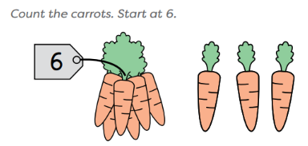  - Count forward from a number other than 1 presented orally (“Count to 10. Start at 3.”)  - Ranges:  - GK with objects/pictures: within 5, then within 10  - GK verbal: within 100  - G1 with objects/pictures: within 20  - G1 verbal: within 120 | - Numbers 1-10 (early in GK)  - Numbers to 20 (later in GK)  - Numbers beyond 20 (G1)  - Span decades (i.e., 29, 30, 31)  - Generate the number just after a given number  - Generate the number just before a given number  - Respond orally or by writing/placing a written number in a blank
Misconceptions
Existing Product Reference, if any | - EM2 GK M5 L18 (with objects)  - EM2 GK M6 L17  - EM2 GK M6 L18  - EM2 GK M6 L19  - EM2 G1 M1 Topic B | - EM2 GK M1 L29  - EM2 GK M1 L30  - EM2 GK M1 L31  - EM2 GK M6 L4  - EM2 G1 M6 L18
Grade (or Leaf) | GK, G1 | GK, G1
Notes related to Standards, Grade, or Leaf | K.CC.A.2  CA.K.CC.2  FL.1.NSO.1.1 | K.CC.B.4.c  CA.K.CC.4.c  FL.K.NSO.2.3  FL.1.NSO.2.3  TX.K.2F  TX.1.2D  TX.2.2C  NE.K.N.2.b  VA.K.NS.1.g  VA.K.NS.1.h
Notes for Intervention, Extension, or Optional Activities | Intervention  - “If children need help with the number-after skill, provide and then fade a ‘running start’.” (Source: Doug and Julie)
Additional Notes | - See Learning Trajectories Counter from N (N+1, N-1) Activities (focus on counting forward)  Fluency Ideas  - Show Me the Math Way: 1 More (EM2 GK M1)  Additional Notes  - “Help children learn the “Counter from N (N+1, N-1)” level of counting well. Children often use the knowledge that n + 1 tasks can be solved by the “number-after” strategy (the counting word after n is the sum) to invent the counting-on strategy.” (Source: Doug and Julie)  Instructional Period  GK: 1-2  G1: 1-2  Associated Concepts from Other Stems  - Whole Numbers and Base Ten Structure  - Lays the foundation for counting on in Addition and Subtraction | Fluency Ideas  - Show Me the Math Way: 1 More (EM2 GK M1)  - Show Me the Math Way: 1 Less (EM2 GK M1)  - Beep Counting (GK M6)  - Imagine 1 More (EM2 G1 M1)  - Imagine 1 More, 1 Less (EM2 G1 M2)  Additional Notes  Associated concepts from other stems:  - Comparing and Ordering  Instructional Period  GK: 1-2  G1: 1 or this might be a part of other instructional periods (comparing and ordering)  Associated Concepts from Other Stems  - Whole Numbers and Base Ten Structure  - Lays the foundation for counting on in Addition and Subtraction

Concept/Skill: Skip-count by tens. (Megan-DONE)

Goal | Efficiently count by grouping and skip-counting by tens
Student-Facing Example | 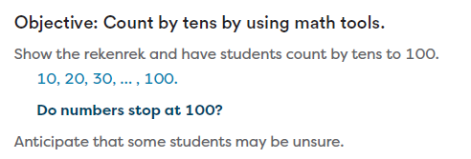
Knowledge Graph Node | Skip-count by tens.
Terminology
Mathematical Models | - 10-frames
Strategies | - Say Ten way  - Fingers  - Wu’s “counting array”
Specifications | - GK: Count by tens to 100  - G1: Count by tens to 120  - G2: Count by tens within 1,000  - With objects  - Make groups of ten to count larger groups of objects efficiently  - Count by tens to determine how many and write the decade number  - Rekenrek  - Counting Collections  - Verbal counting  - Choral counts
Leaves to Include | Do we need a leaf for starting number? SC has a standard noted below that requires counting by tens from any multiple of five to 100.
Considerations | - See groups of 10 within a set and count those groups by 10 (relates to multiplication and algebraic thinking)  - Rekenrek  - Verbal and object counting by 10s
Required Skills/Cases | - GK: to 100  - G1: to 120  - G2: within 1,000
Misconceptions
Existing Product Reference, if any | EM2 GK M6 Topic C  EM2 G2 M1 L22 Launch (choral count)
Grade (or Leaf) | GK, G1, G2
Notes related to Standards, Grade, or Leaf | K.CC.A.1  2.NBT.A.1.a  2.NBT.A.2  CA.K.CC.1  CA.2.NBT.1.a  CA.2.NBT.2  FL.K.NSO.2.1  TX.K.5A  TX.1.5B  NE.K.N.2.f  ID.1.NBT.A.1  MD.2.NOS.A.2.a  SC.1.NR.2.2—note this standard requires counting by tens from any multiple of five to 100  VA.1.NS.1.c
Notes for Intervention, Extension, or Optional Activities | Intervention  - Say: “Count with me. Count by tens.” (If you are counting items, move the appropriate amount with each count.) (Source: Doug and Julie)  - Say: “Count by tens like this: (demonstrate). Now, count with me.” (Source: Doug and Julie)
Additional Notes | Fluency Ideas  - Happy Counting by Tens (GK M6)  - Sunrise, Sunset Counting (GK M6)  - Counting on the Rekenrek by Tens (G1 M1 and G2 M1)  Additional Notes  - “Counting groups of objects helps children understand the quantities as they are built up. Discussions emphasize that thirty means 3 tens and fifty mean five tens.” (Source: Learning Trajectories website)  Instructional Period  GK: 1  G1: 1  G2: 1  Associated Concepts from Other Stems  Whole Numbers and Base Ten Structure

Concept/Skill: Count to 100 by ones. (Megan-DONE)

Goal | Understand the decade number words and decade transitions
Student-Facing Example | 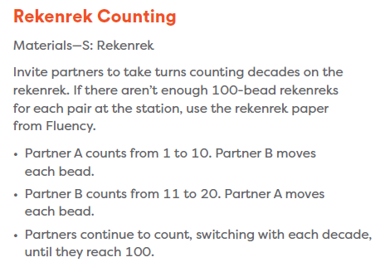
Knowledge Graph Node | Count to 100 by ones.
Terminology
Mathematical Models | - 10-frames
Strategies | - Choral Counting  - Wu’s “counting array”
Specifications | - Starting from 1  - Starting from a number other than 1 (i.e., from 61 to 100—see GK M6 L17 Launch as an example)  - Use tools, such as choral counting chart or rekenrek  - Choral count, record on chart paper, look for and discuss patterns  - Within and across decades  - Make accurate decade transitions (e.g., “39, 40”; “59, 60”)  - Understand and make use of patterns:  - The ones digits 1–9 repeat within every decade  - Tens digit changes when crossing a decade boundary
Leaves to Include
Considerations | - Make accurate decade transitions starting at any number  - Rekenrek  - Include verbal and object counting  - Use pattern and structure to master the count to 100
Required Skills/Cases | - Count to 100 by ones starting at 1  - Count to 100 by ones starting at a number other than 1 (i.e., from 61 to 100)  - Make accurate decade transitions
Misconceptions | - Difficulty with decade transitions (for example, a student may not be able to transition to the next decade number without prompting or may repeat a decade number rather than transitioning (“58, 59…50!”))
Existing Product Reference, if any | - EM2 GK M6 L17
Grade (or Leaf) | GK
Notes related to Standards, Grade, or Leaf | K.CC.A.1  CA.K.CC.1  FL.K.NSO.2.1  TX.K.5A  NE.K.N.2.f  ME.PK.MELDS.M.CCC.PS.1  AK.PK.34.12
Notes for Intervention, Extension, or Optional Activities
Additional Notes | Fluency Ideas  - Fitness Counting (GK M6)  Instructional Period  1-2 with lots of Fluency/Practice added in  Associated Concepts from Other Stems  Whole Numbers and Base Ten Structure

Concept/Skill: Count on from a given number by using spatial, auditory, or rhythmic patterns to keep track of how many have been counted. (Stella – DONE)

Goal | Count on from a given number a small number of times by using rhythmic subitizing
Student-Facing Example | - A child is asked, "How much is 2 more than 5?" Child feels two "beats" as she counts, "5...6, 7!"  - A child has counted three toys that were placed in a box. A teacher adds three more, dropping each noisily, then asks “How many there are?” The child answers “There were three… so, three… four, five, six. Six!”
Knowledge Graph Node | Count on from a given number by using spatial, auditory, or rhythmic patterns to keep track of how many have been counted.
Terminology
Mathematical Models | - Manipulatives  - Dot Cards
Strategies
Specifications | GK:  - Count on 1 or 2 more within 5 (early)  - Count on up to 3 more within 10 (later)  - Use dot cards, manipulatives, and movement routines  - Begin conceptual subitizing with structured patterns (5-groups, dice patterns)  G1:  - Count on within 20  - Use count-on strategies, such as keeping track, fluently for addition and simple subtraction/count-up situations  - Transition from perceptual supports toward mental counting strategies
Leaves to Include
Considerations | - Counting on 1 to about 3 more  - For example, starting at 4 and counting three more in rhythmic (doo-doo-DAH!) helps children learn the count on strategy
Required Skills/Cases | GK:  - Count on up to 3 more within 10  G1:  - Count on within 20
Misconceptions | - Students count all, even with small quantities (e.g., “I touch and count to make sure I count each one”).  - Fluency activities such as Finger Flashes encourage students to trust their ability to recognize small quantities instantly. (Source: TX BB Learning G1 M1)  - Students rely on counting all (e.g., “I have to count from 1”). (  - Make 5-group cards available for partner activities or at centers. To support counting on, have Partner A show a numeral. Have Partner B show a number of dots and count on to find the total (e.g., “Siiiix, 7, 8, 9.”) (Source: TX BB Learning G1 M1)
Existing Product Reference, if any | GK M5  G1 M1
Grade (or Leaf) | GK, G1
Notes related to Standards, Grade, or Leaf | K.CC.A.2  K.CC.B.4.c  K.CC.B.5  1.OA.C.5  1.OA.C.6  OR.PK.OA1 not numbered  SD.K.CC.A.2  VA.CD3.2e
Notes for Intervention, Extension, or Optional Activities | Intervention  See Math Catalyst- Count On to Add Within 10
Additional Notes | Associated concepts from other stems:  - Addition and Subtraction  Lesson Ideas:  GK M5 L7  GK M5 L18  GK M6 L5, 16, 17, 18, 19  G1 M1 TB, TC  Fluency ideas (GK M1, M5, M6):  - Counting with Movement to 10  - 5–Group Hands  - Coin Drop: Add 1  - Beep Counting  - Counting on the Rekenrek  - Fitness Counting  Margin box ideas:  GK M1 L1 UDL: Engagement  GK M1 L29 UDL: Action & Expression  Instructional period:  GK- Likely 1 period  G1- Likely 1 period

Concept/Skill: Skip-count by twos and fives. (Stella- DONE)

Goal | Efficiently count by grouping and skip-counting by fives and twos
Student-Facing Example | 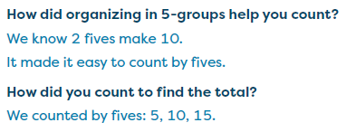 |  | 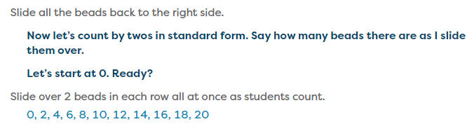
Knowledge Graph Node | Count a collection of objects efficiently by grouping the objects and skip-counting by twos. | Count a collection of objects efficiently by grouping the objects and skip-counting by fives.
Terminology
Mathematical Models | - Number path/line | - Number path/line
Strategies | - Manipulatives and everyday objects (in groups of 2)  - Number path/line  - Wu’s “counting array”  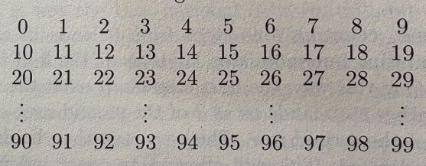 | - Manipulatives and everyday objects (in groups of 5)  - Number path/line  - Wu’s “counting array”
Specifications | - Skip-count by 2s to determine totals up to 120.  - Count collections arranged in pairs.  - Complete count-by-2 sequences.  - Count larger collections (within 1,000) by twos.  - Relate counting by twos to even numbers and equal groups | - Connect to tally marks, fingers, and nickels.  - Make equal groups of 5 and use groups of 5 to find a total.  - Skip-count by 5s within larger ranges (within 1,000) and use grouping by 5 as an efficient strategy.  - Connect to place value, arrays/equal groups, money, and repeated addition.
Leaves to Include
Considerations | - Verbal and object counting  - Counting groups of objects helps children understand the quantities as they build  - Use items to emphasize sets of two | - Verbal and object counting  - Counting groups of objects helps children understand the quantities as they build  - Use items to emphasize sets of five; put the sets of five next to each other creating sets of ten
Required Skills/Cases | - Skip-count by 2s to determine totals up to 120.  - Count collections arranged in pairs or by grouping objects.  - Complete count-by-2 sequences: 2, 4, 6, 8, 10, __, 14.  - Count larger collections by grouping objects and counting by twos.  - Explain why skip-counting is more efficient than counting by ones.  - Relate counting by twos to even numbers and equal groups | - Connect to tally marks, fingers, and nickels.  - Make equal groups of 5 and use groups of 5 to find a total.  - Skip-count by 5s within 1000  - Connect to place value, arrays/equal groups, money, and repeated addition.  - Complete count by 5 sequences: 5, 10, __, 20, 25
Misconceptions
Existing Product Reference, if any | In G1, counting by twos is mostly seen in Fluencies and in Counting Collections.  - G1 M1, M2, M5  - G1 M1, M2, M4, M6- TX BB Learning  - G2 M1, M3, M6 | In G1, counting by fives mostly seen in Fluencies and in Counting Collections.  - G1 M1, M2, M5  - G1 M1, M2, M4, M6- TX BB Learning  - G2 M1, M3, M6
Grade (or Leaf) | G2 | G2
Notes related to Standards, Grade, or Leaf | 2.OA.C.3  CA.2.OA.3  MD.2.NOS.A.2.a  VA.2.NS.1.c  MN.2.3.7.2  Notes related to Standards:  Counting by twos CCSSM standard is formally introduced in G2.  Skip-count by twos standard formally introduced in G1 in other states:  FL.1.NSO.1.1  TX.1.5B  AK.1.CC.1  ID.1.NBT.A.1  VA.1.NS.1.d | 2.NBT.A.2  CA.2.NBT.2  MD.2.NOS.A.2.a  VA.2.NS.1.c  MN.2.3.7.2  Notes related to Standards:  Counting by fives CCSSM standard is formally introduced in G2.  Skip-count by fives standard formally introduced in G1 in other states:  FL.1.NSO.1.1  TX.1.5B  AK.1.CC.1  ID.1.NBT.A.1  MO.1.NS.A.4  SC.1.NR.2.2  VA.1.NS.1.c
Notes for Intervention, Extension, or Optional Activities | Intervention  - Count shoes, arms, or legs by twos. (Source: Learning Trajectories)  - Provide a Hundred Chart as a visual guide. (Source: Learning Trajectories, Skip Counters)  Extension  - If children find counting by twos too easy, skip count other items by threes or fours (e.g., number of wheels on toy cars, number of “corners” on triangular pattern blocks, number of dots on multiple dot pattern cards or dice–when they each show the same number of dots) (Source: Learning Trajectories, Skip Counters)  - Consider sequences such as 3,5,7,9 … | Intervention  - Count the number of fingers in the class by fives. (Source: Learning Trajectories)  - Provide a Hundred Chart as a visual guide. (Source: Learning Trajectories, Skip Counters)  Extension  - If children find counting by fives too easy, skip count other items by threes or fours (e.g., number of wheels on toy cars, number of “corners” on triangular pattern blocks, number of dots on multiple dot pattern cards or dice–when they each show the same number of dots) (Source: Learning Trajectories, Skip Counters)
Additional Notes | Associated concepts from other stems:  - Measurement and Data (Time)  - Lays the foundation for Multiplication  Fluency Ideas  - Finger Flash: Doubles (EM2 G1 M1 TC L16)  - Choral Response: Doubles on the Rekenrek (EM2 G1 M1 TD L22)  - Skip-Counting Squats (G1 M1 L8- TX Bluebonnet Learning)  - Sparkle: Counting by Twos (G1 M1 L22- TX Bluebonnet Learning)  - Happy Counting by Twos (G1 M1 L23-TX Bluebonnet Learning)  - Partner Counting by Twos (G1 M1 L24-TX Bluebonnet Learning)  - Counting on the Rekenrek by Twos (EM2 G2 M6)  Additional Notes  - EM2 G1 M1 TD L25 (optional)– Counting Collections: Through comparing and connecting strategies, students recognize the value of organizing objects into groups to count efficiently.  - EM2 G1 M6 L15, 16- Bluebonnet Learning  Counting collections lessons:  - EM2 G1: M1 L25  M5 L2  - EM2 G2: M1 L23, L37  M4 L1, L24  M5 L1  M6 L2  Instructional periods:  - Likely 2 periods with lots of Fluency activities added in | Associated concepts from other stems:  - Measurement and Data (Time)  - Lays the foundation for Multiplication  Fluency Ideas  - Sprint: Count by Fives  - Counting on the Number Line by Fives Within 60  - Counting on the Clock (EM2 G2 M3 L19)  - Counting the Math Way by Tens, Fives, and Twos (EM2 G2 M6)  Additional Notes  - Include problem-solving context involving collections, pairs, nickels, clocks/time, arrays, measurement context  - EM2 G2 M1 TE L23 – Organize, count, and record a collection of objects  - EM2 G2 M3 TD L17– Relate the clock to a number line to count by fives.  - EM2 G2 M6 TA L2 – Count Equal Groups of 2, 5, and 10  Instructional periods:  - Likely 2 periods with lots of Fluency activities added in

Concept/Skill: Count forward or backward from a given number. (Stella- DONE)

Goal | Efficiently count by counting on or counting back (instead of counting all)
Student-Facing Example | 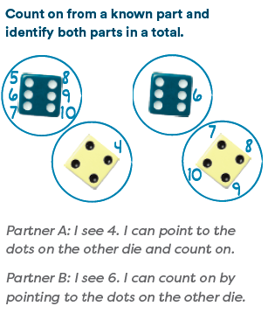
Knowledge Graph Node | Count forward or backward from a given number.
Terminology
Mathematical Models
Strategies | - Manipulatives/counters  - Number path/line  - Wu’s “counting array”
Specifications | - Start counting from a number other than 1.  - Count forward by ones from a given number.  - Count backward by ones from a given number.  - Continue a counting sequence with missing numbers.  - Use tools such as fingers, number paths, number lines, or hundreds charts.  - Connect counting forward with addition and counting back with subtraction.
Leaves to Include
Considerations | - First with objects, then by “counting counts”  - Keep track of counting acts numerically (e.g., by using fingers)  - Use commutativity to count on from either part  - foundational to more efficient addition strategies, mastery of facts within 20, and finding an unknown part
Required Skills/Cases | - Count forward: “Start at 6. Count to 10.”  - Count backward: “Start at 9. Count back to 4.”  - Fill in the missing numbers: “12, 13, ___, 15.”  - Count within 10  - Count within 20  - Count within 100  - Start at teen numbers.  - Cross decade numbers: 18, 19, 20, 21  - Count backward across a decade: 32, 31, 30, 29.  - Count with written numerals and oral counting.  - Count using visual supports, then without supports.
Misconceptions | - Students use the pronunciation of teen numbers as a basis for writing digits (e.g., fourteen is written as 41 instead of 14).  - Say Ten counting highlights the base-ten structure within teen numbers. Place value cards support understanding that the digit 1 in a teen number represents 10 ones. Include Say Ten Counting and Decompose Teen Numbers fluency activities. (Source: TX BB GK M1)ˆ  - Students memorize the number word list in only a forward direction.  - Use fluency activities such as a Rekenrek Roller Coaster to practice sequences that switch directions (e.g., 1, 2, 3, 2, 3, 4, 5, 6, 5, 6). (Source: TX BB GK M1)
Existing Product Reference, if any | - Math Catalyst: Addition — Add Within 20  - EM2 GK M5 TC L18, L22, L2  - EM2 GK M6 TA L5, TC L17, L18, L19
Grade (or Leaf) | GK
Notes related to Standards, Grade, or Leaf | K.CC.A.2  CA.K.CC.2  FL.K.NSO.2.1  TX.K.2A  TX.K.5A  ID.K.CC.A.2  ND.K.NO.CC.2  SD.K.CC.A.2  VA.K.NS.1.f  PreK Standard:  SD.PK.CD-4.g (count backward from 5 using fingers)  G1 Standards:  FL.1.NSO.1.1  TX.1.5A  AL.1.NBT.10.a  ID.1.NBT.A.1  MO.1.NS.A.3  ND.1.NO.CC.2  NE.1.N.2.b
Notes for Intervention, Extension, or Optional Activities | - Concrete-Pictorial-Abstract  Intervention Ideas:  - Math Catalyst: Addition-Add Within 20
Additional Notes | Fluency Ideas:  EM2 GK:  - Counting on the Number Glove Within 3 (GK M1 L1)  - Say Ten Push-Ups (GK M5 L20)  - Counting on the Rekenrek the Say Ten Way(GK M6 L1)  - Counting on the Rekenrek (GK M6 L4)  Associated concepts from other stems:  - Whole Numbers and Base Ten Structure  - Addition and Subtraction  Instructional periods:  - Likely 2 periods

Concept/Skill: Count by different units, such as tens and ones, by switching units within the same count. (Stella – DONE)

Goal | Skip-count efficiently and flexibly
Student-Facing Example | 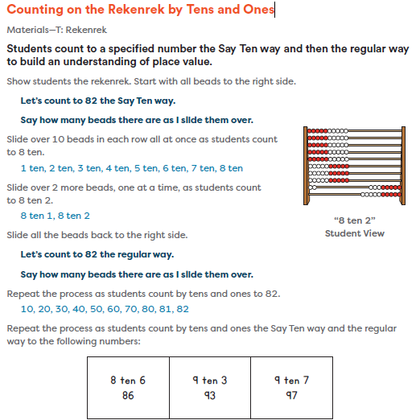
Knowledge Graph Node | Count by different units, such as tens and ones, by switching units within the same count.
Terminology
Mathematical Models
Strategies | - Manipulatives: Bundles  - Money  - Number line  - Wu’s “counting array”
Specifications | - Count by tens to a benchmark number and continue by ones.  - Ex. 10, 20, 30, 31, 32, 33  - Count from a non-benchmark number using mixed units.  - Ex. 24, 34, 44, 45, 46  - Flexibly switch between units based on the situation.  - Ex. 4 tens and 7 ones 10, 20, 30, 40, 41, 42, 43, 44, 45, 46, 47  - Ex. A student needs to find the total number of stickers if there are 38 stickers and 5 more are added. 10, 20, 30, 35, 36, 37, 38, 39, 40, 41, 42, 43
Leaves to Include
Considerations | - Include multiples of hundreds, tens, ones, and other standard and non-standard units  - Decompose a 10 if it’s useful when counting groups of 10  - Heavy ties to place value understanding
Required Skills/Cases | - Count from 0 by tens then ones.  - Count from a multiple of 10 by tens then ones.  - Count from 0 by hundreds, then tens, then ones.  - Count from a multiple of 100 by hundreds, then tens, then ones.  - Count from any number by ones to a multiple of 10 then count by tens.  - Count from any number by ones to a multiple of 10, then by tens to a multiple of 100, then by hundreds.
Misconceptions
Existing Product Reference, if any | - EM2 G1 M5 Topics A–B  - Math Catalyst: Compare and Order Numbers to 120
Grade (or Leaf) | G1
Notes related to Standards, Grade, or Leaf | 1.NBT.B.2  CA.1.NBT.2  TX.1.2B  TX.1.5A  FL.1.NSO.1.3
Notes for Intervention, Extension, or Optional Activities | Intervention, Extension, or Optional Activities Ideas:  From EM2 GK M1, M5:  - Use fluency activities such as Rekenrek Roller Coaster to practice sequences that switch directions (e.g., 1, 2, 3, 2, 3, 4, 5, 6, 5, 6).  - Math Catalyst- Compare and Order Numbers to 120  - Counting: Counter of Quantitative Units/Place Value (Source: Learning Trajectories)
Additional Notes | Fluency Ideas:  EM2 G1 M1:  - Happy Counting by Ones Within 20  - Happy Counting by Ones Crossing 20  - Say Ten Push-Ups  EM2 G1 M5:  - Counting on the Rekenrek by Tens and Ones  - Choral Response: 5-Groups to 20 with Pennies and Dimes  - Choral Response: 5-Groups to 30 with Pennies and Dimes  - Whiteboard Exchange: Model Numbers with Quick Tens and Ones  Associated concepts from other stems:  - Whole Numbers and Base Ten Structure  - Measurement and Data (Time, Money)  Instructional periods:  - Likely 2 periods

Concept/Skill: Count beyond 100 by applying patterns of ones, tens, and hundreds. (Megan—DONE)

Goal | Apply patterns and structures from counting to 100 to count beyond 100
Student-Facing Example | 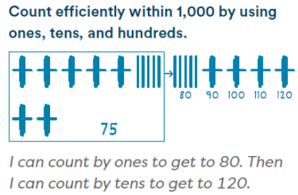
Knowledge Graph Node | Count beyond 100 by applying patterns of ones, tens, and hundreds.
Terminology
Mathematical Models | - Number Line
Strategies | - Manipulatives: Bundles  - Wu’s “counting array”
Specifications | - G1: to 120  - G2: to 1,000 (1,200 for certain states)  - Count by ones beyond 100 (i.e., to 120)  - Understand and make use of patterns:  - The ones digits 1–9 repeat within every decade  - Tens digit changes when crossing a decade boundary  - Hundreds digit changes when crossing a hundred boundary  - Skip count for efficiency (by tens, hundreds)  - Count forward starting at any number  - Make accurate decade and hundred transitions  - I know the next number after 629 is 630  - I know the next number after 799 is 800  - Understanding of number words (e.g., 30 is 3 tens; 630 is 6 hundreds and 3 tens)  - Leads into place value: relationship between ones and tens & tens and hundreds
Leaves to Include | To 1,000 in G2 (or 1,200 for different states)
Considerations | - Verbal and object counting  - Understanding the decade number words and transitions between units (e.g., after 99 comes 100, which means 100 ones or 10 tens)
Required Skills/Cases | - G1: to 120  - G2: to 1,000  - Count forward from any number  - Skip count (by tens, hundreds) from any number (ex. 42, 52, 62)  - Make accurate decade and hundred transitions
Misconceptions | - Difficulty with decade or hundred transitions (for example, a student may not be able to transition to the next decade number without prompting or may repeat a decade number rather than transitioning (“58, 59…50!”))
Existing Product Reference, if any | - EM2 G1 M6 Topic D  - EM2 G2 M1 Part 2
Grade (or Leaf) | G1, G2
Notes related to Standards, Grade, or Leaf | 1.NBT.A.1  2.NBT.A.1  2.NBT.A.2  2.NBT.B.8  CA.1.NBT.1  CA.2.NBT.1  CA.2.NBT.2  CA.2.NBT.8  FL.2.NSO.2.2  TX.1.5A  TX.1.5C  TX.2.7B  MD.2.NOS.A.2.a  MN.2.3.7.2  NE.1.N.2.d  ND.1.NO.CC.5  VA.2.NS.1.b  VA.2.NS.1.c
Notes for Intervention, Extension, or Optional Activities | Intervention  - Math Catalyst: Place Value: Compose, Decompose, and Represent Numbers to 120, Objective 3
Additional Notes | Fluency Ideas  - Happy Counting  - Counting on the Rekenrek  - Counting with Ones, Tens, and Hundreds (EM2 G2 M1)  Instructional Period  - G1: 1-2 with plenty of Fluency/Practice added in  - G2: 3 with plenty of Fluency/Practice added in  Associated concepts from other stems  - Whole Numbers and Base Ten Structure

Concept/Skill: Understand that the number of objects in a group is not affected by how the objects are arranged or the order they are counted in. (Megan-DONE)

Goal | Understand that the number of objects is the same regardless of their arrangement or the order in which they were counted
Student-Facing Example | 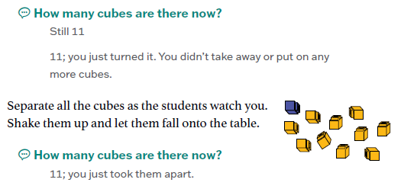
Knowledge Graph Node | Understand that the number of objects in a group is not affected by how the objects are arranged or the order they are counted in.
Terminology
Mathematical Models
Strategies | - Manipulatives/counters
Specifications | - Collections with up to 5 objects  - Collections with up to 10 objects  - Collections with up to 20 objects  - Recognize the number of objects is the same even when objects in a collection are rearranged  - Students may start off recounting to verify, and eventually progress to not needing to recount  - Incorporate collections spaced closely together and then further apart  - Recognize the number of objects is the same even when counting the objects in a different order  - Incorporate opportunities for students to count the same collection from a different starting place and compare results  - Emphasize the “why” of conservation: the number doesn’t change because no objects were added or taken away  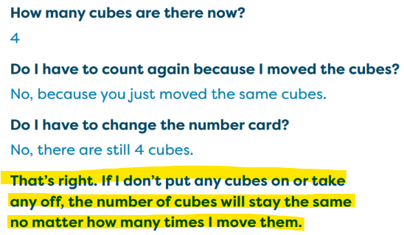
Leaves to Include
Considerations | - Understand that the number has been unchanged even in face of perceptual distractions such as spreading out objects of a collection.  - Recognize that the number in a set does not change unless some are added or subtracted  - Recognize the number of objects in a group is the same after rearrangement without counting
Required Skills/Cases | - Collections with up to 5 objects  - Collections with up to 10 objects  - Recognize that the number of objects in a collection is the same even when the objects are rearranged, without recounting  - Example from Doug and Julie: Counts two rows that are laid out across from each other and says they are the same. Adult spreads out one row. Says, “Both still have the same number; one’s just longer.”  - Recognize that the number of objects in a collection is the same even when the objects are counted in a different order
Misconceptions | - Students may think the number of objects has increased when objects are spread out, or they may perceive that a row of 7 cubes all spread out has “more” than a row of 7 cubes spaced closely together due to differences in length
Existing Product Reference, if any | - EM2 GK M1 L9  - EM2 GK M1 L23
Grade (or Leaf) | GK
Notes related to Standards, Grade, or Leaf | K.CC.B.4.b  FL.K.NSO.1.1  TX.K.2C
Notes for Intervention, Extension, or Optional Activities | Intervention  - See Math Catalyst: Early Numeracy: Verbal and Object Counting to 10, Objective 2  - See Math Catalyst: Early Numeracy: Verbal and Object Counting to 20, Objective 2
Additional Notes | Additional Notes  - “Teacher Tip” from Math Catalyst: Early Numeracy: Verbal and Object Counting to 5:  - Showing the same 3 cubes arranged in different ways and asking how many each time allows students to experiment with conservation of numbers and builds the understanding that the number of objects in a group remains the same no matter how the objects are arranged. Consider providing additional opportunities to practice throughout the day by having students count groups of classroom objects, move the objects, and then tell how many without recounting.  Instructional Period  2 (1 for arrangement, 1 for order)

Concept/Skill: Count forward and backward by 1s and 10s, from any number, to solve problems. (Katie)
Goal | Count by different units to solve arithmetic-like problems
Student-Facing Example | 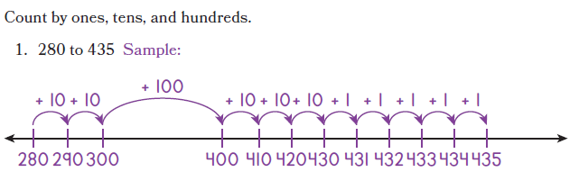
Knowledge Graph Node | Count forward and backward by 1s and 10s, from any number, to solve problems.
Terminology
Mathematical Models | - Number line
Strategies | - Manipulatives: Bundles, $1, $10, and $100 bills  - Number line  - Number stairs  - Rekenrek  - Wu’s “counting array”
Specifications | - Pattern of 1 more and 1 less (next number is 1 more; previous number is 1 less)  - Pattern of 10 more and 10 less  - The ones digits 1–9 repeat within every decade  - Tens digit changes only when crossing a decade boundary
Leaves to Include | - Number range
Considerations | - Count “counting words” in either direction starting at any number (single sequence or skip counts)  - Count backward from 20+ with meaning  - Recognize that decades sequence mirrors single-digit sequence  - Include 0  - Switch between sequence and composition views of multi-digit numbers easily  - Relate counting forward and counting back to addition and subtraction
Required Skills/Cases | - Counting forward by 1s from any number  - Counting backward by 1s from any number  - Counting forward by 10s from any number  - Counting backward by 10s from any number  - Counting across decade and hundred boundaries (e.g., 28, 29, 30, 31)
Misconceptions | - Loses track of direction when switching between forward and backward  - Thinks counting backward by 10s changes the ones digit (e.g., 54 → 43 instead of 44)
Existing Product Reference, if any | Count by 1s — applied to solving problems  - G1 M1 (Topics A–D) — count all / count on to solve put-together and add-to problems (e.g., count on from a known part; count on from the larger addend using the commutative property)  - G1 M2 TB L7 — count on or count back to solve related addition and subtraction  - G1 M2 TD L15 — relate counting on and counting back to find an unknown part  - G1 M3 TE L23 — subtract by counting on; decompose the subtrahend to count back  - G2 M1 TD L18 — choose the efficient direction: count on to add, count back to subtract  Count by 10s — applied to solving problems  - G1 M3 TC L14 — count on to make the next ten within 100  - G1 M5 TD L15 — count on and back by tens to add and subtract  - G2 M1 TG L29 — add 10 by hopping on the number line (e.g., start at 65, add 10)  - G2 M2 TA L2 — add tens to tens using place value (counting by tens to add)
Grade (or Leaf) | - Grade: Begins in GK with counting by ones  - In G2, switching between units  - Leaf: Money
Notes related to Standards, Grade, or Leaf | FL.1.NSO.1.1  TX.1.5A  AK.1.CC.3  AK.PK.34.12  AL.K.FC.1  ID.K.CC.A.2  KY.K.CC.1.b  MD.PK.NOS.A.2  MD.2.NOS.A.2.a  MN.PK.M1.14  ND.K.NO.CC.2  NE.1.N.2.b  SD.PK.CD-4.g  SD.K.CC.A.2  VA.K.NS.1.f  WY.K.CC.1B  - TX.1.5C  - ND.1.NO.CC.5  - AL.K.FC.1  - AL.1.NBT.10.a  - MD.2.NOS.A.2.a  ND.1.NO.CC.5
Notes for Intervention, Extension, or Optional Activities | Catalyst:  - Verbal and Object Counting to 5  - Verbal and Object Counting to 10  - Verbal and Object Counting to 20
Additional Notes | G1: Likely 2 instructional periods  G2: Likely 2 instructional periods  (relies on continued practice in other contexts)  Associated concepts from other stems:  - Whole Numbers and Base Ten Structure  - Addition and Subtraction

